Haskayne Students’ Association
Interim Vice President Position Voting Results 2020
As following the Haskayne Students Association Constitution, those who voted on the results of the HSA Interim Vice President positions are the incoming members of the HSA Executive Committee which consists of:
- Haskayne Students’ Association President: Akari Maeda
- Vice President Operation and Finance: Avery Mather-Shapiro
- Vice President External: Kareena Makhija
- Vice President Academic: Emily Chen
- Vice President Student Life: Adrian Alcantara
- Students Union Faculty Representative: Aly Samji
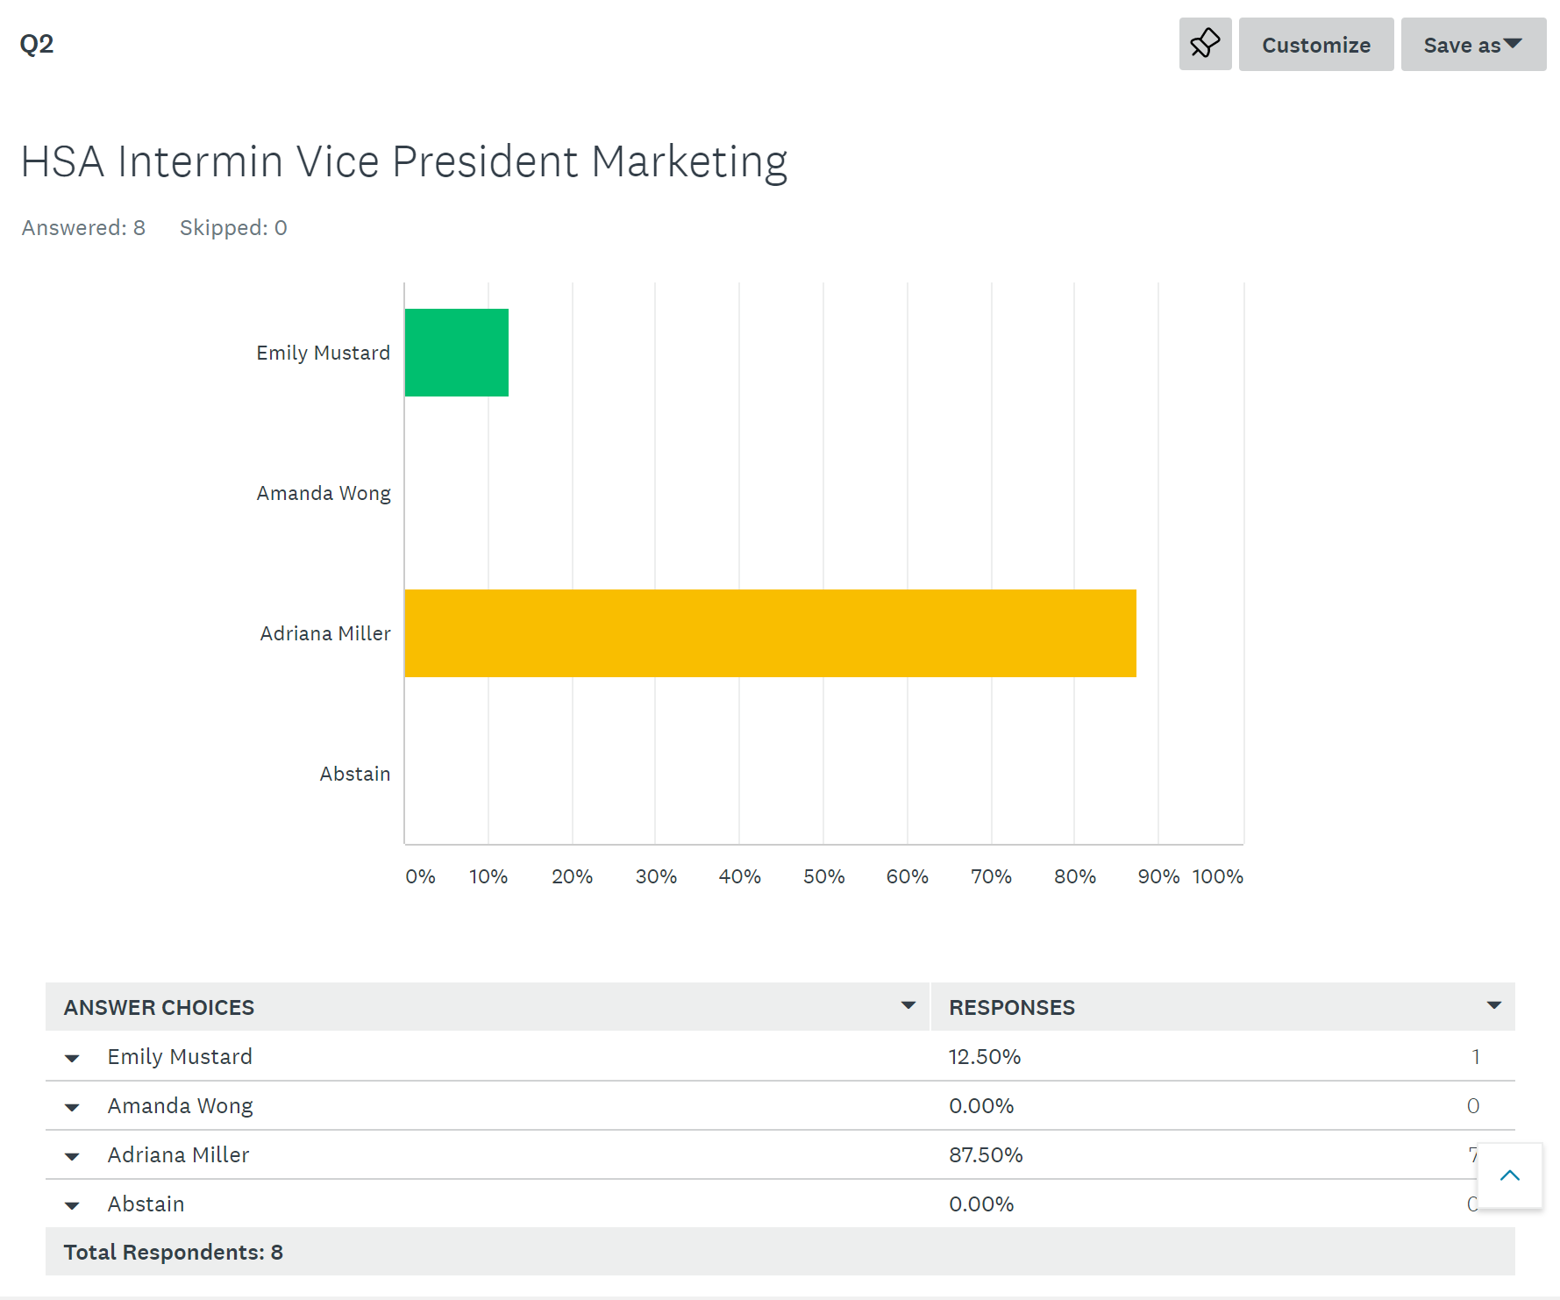
- Students Union Faculty Representative: Shagufta Farheen
